**DOCUSIGN FUNCTIONALITY TO VALIDATE ORGANIZATION CONTRACTS**

1.Create a new account by using the following URL: <https://secure.docusign.com/signup/develop>

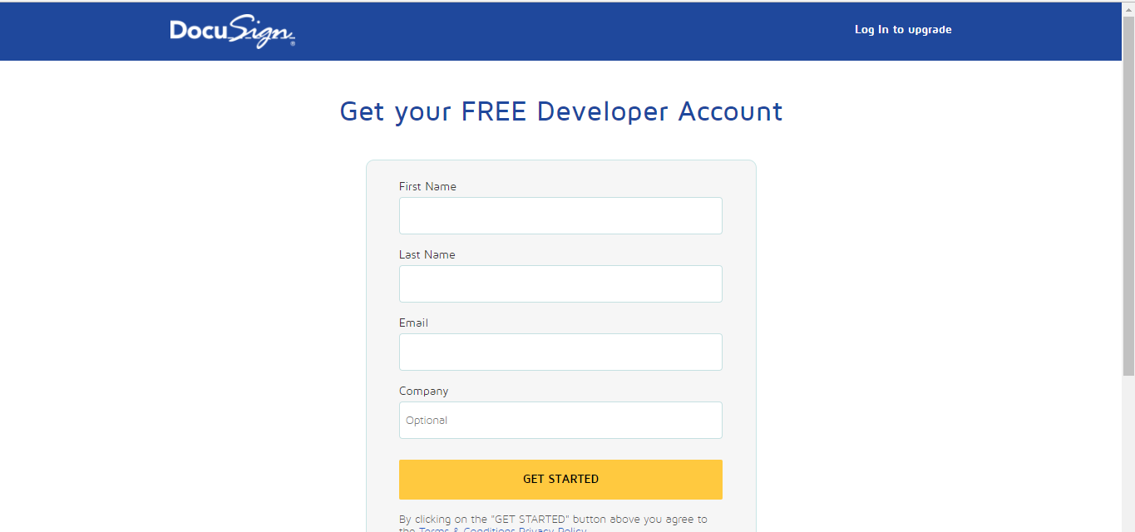

2.Login with Tenant Credentials, Navigate to Settings>Configurations, move to DocuSign Settings.

1. Enable the DocuSign functionality
2. Enter DocuSign username and password in the fields mentioned.
3. Enter the Integrator key of DocuSign from My Account>Go to Admin>Integrations>API and Keys and copy the key and paste in Global>Configurations>DocuSign Settings.

https://admindemo.docusign.com/api-integrator-key

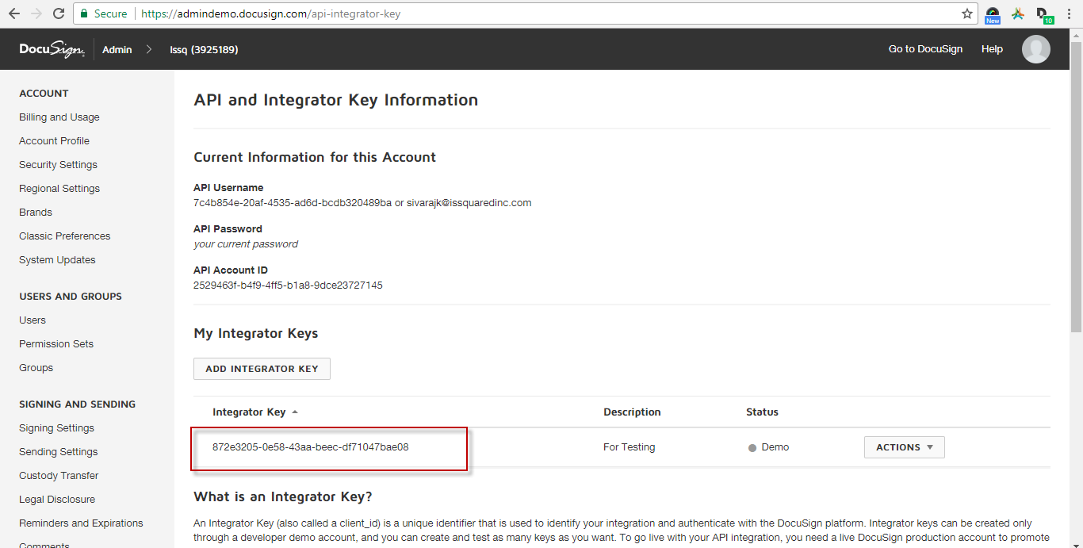

1. Enter the API Client URL as mentioned below: <https://demo.docusign.net/restapi>

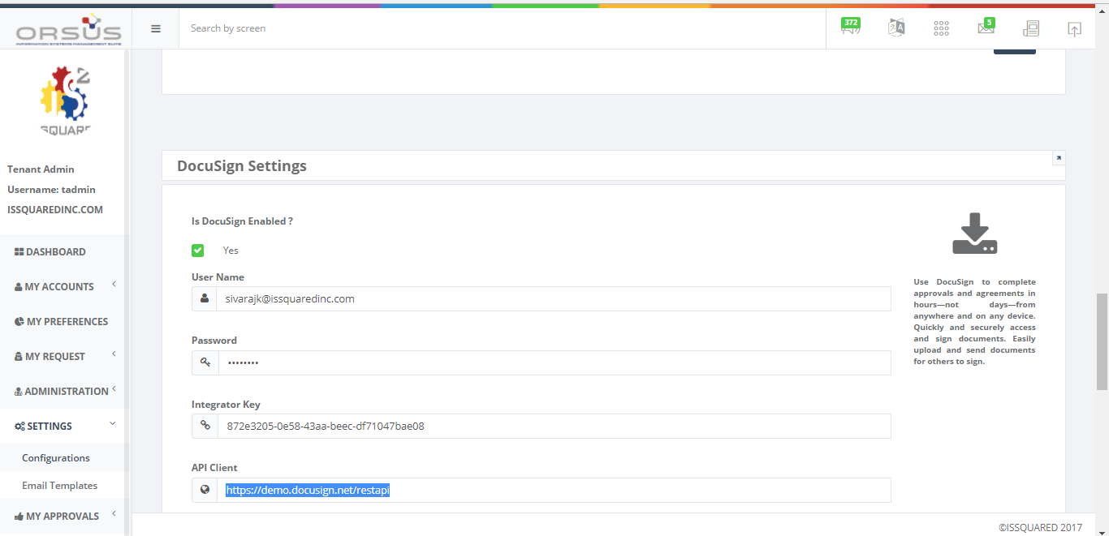

3.Click on Administration>Windows Services>Select Service name as DocuSign, click on OK.

4. Copy the service key click on save and paste this key in the Remote Web Services>.Config file and start the service.

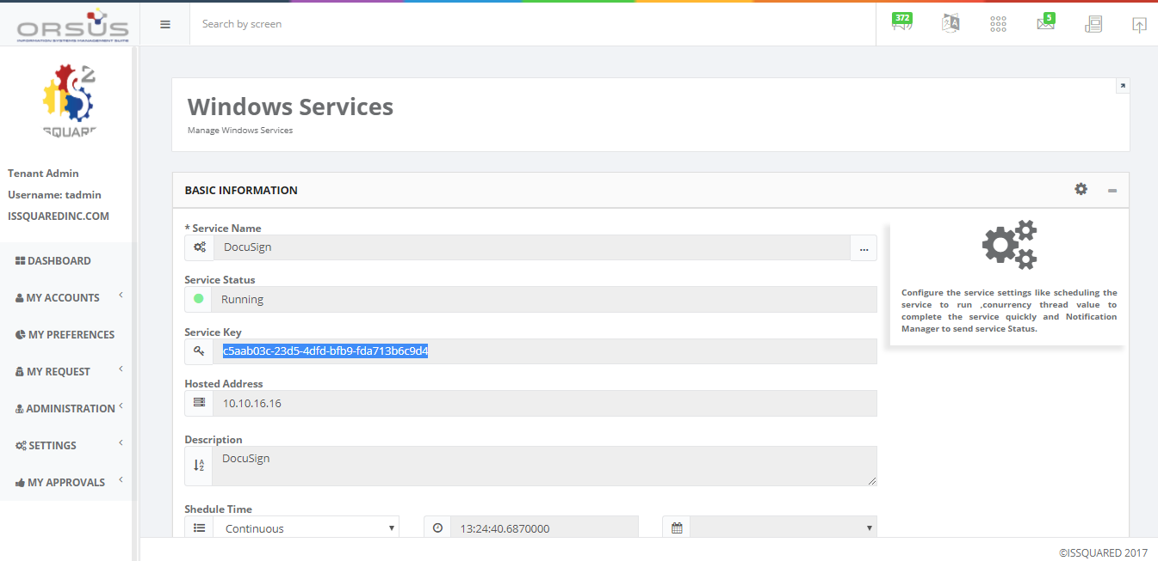

***\*\*\*\*\*To run the DocuSign functionality then the status of DocuSign Service should be in, “Running” State. \*\*\*\*\****

5.Now select Organizations icon from the dashboard screen and click on My organizations from the left menu, select Contracts.

6.Click on New or select one record, click on edit from the top menu, create some contract signatures by clicking on create new, enter data in all fields, click on Save.

7.Now click on Documents tab, enter data in all fields, upload a PDF document, click on Save.

(**PDF Document Creation Process:**

DOCUSIGN SAMPLE TEMPLATE

USERNAME: ------------------------------------------------------

Signature 1 : --------------------The names are treated as anchor tags and this names should be same as the names which you mention in DocuSign Envelope screen.

Signature 2 : ----------------------

Signature 3 :------------------------

***\*\*\*If the signature names in contracts>DocuSign screen does not match with the anchor tags in document then the functionality will not work, Error messages will get displayed in Windows Services>DocuSign>External Links>Service Log list. \*\*\*\*\****

----🡪Save the above document as sample.pdf and upload this document in Documents tab.

8.Click on External links, select **Request for DocuSign**.

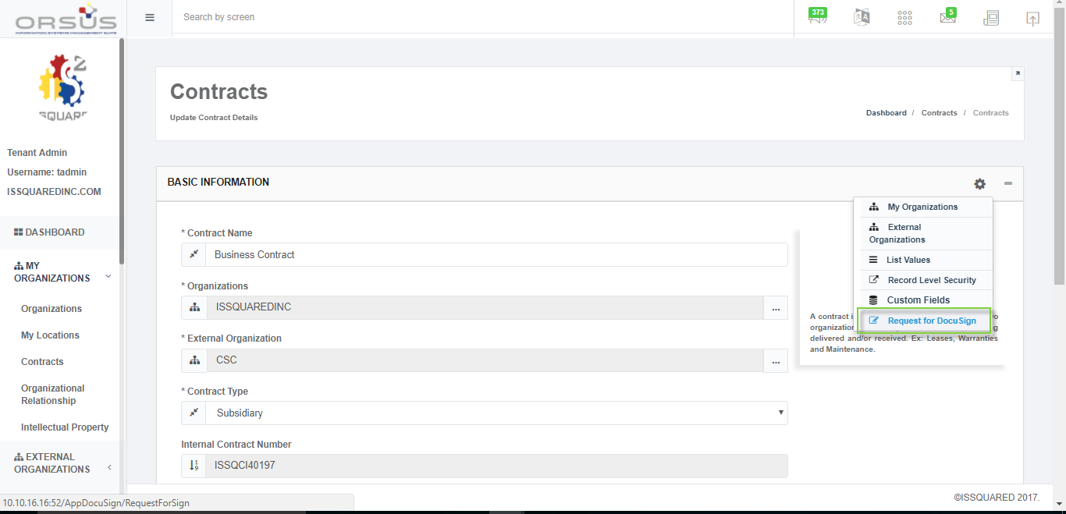

9. Click on, **“CREATE NEW ENVELOPE”**

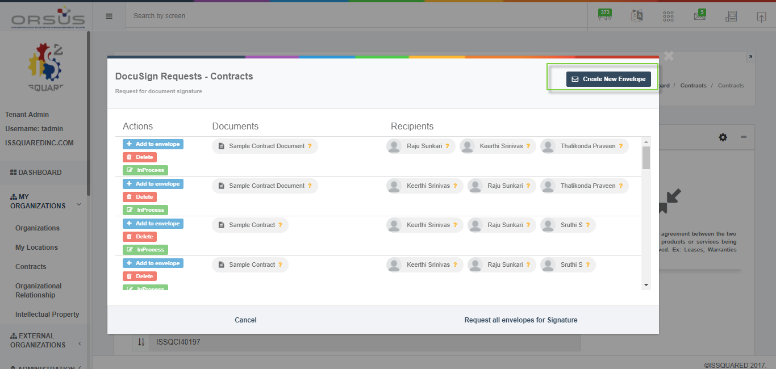

10.Click on Document which is uploaded, and select the users as per the signatures tags which are given in the document and click on Request for Signature.

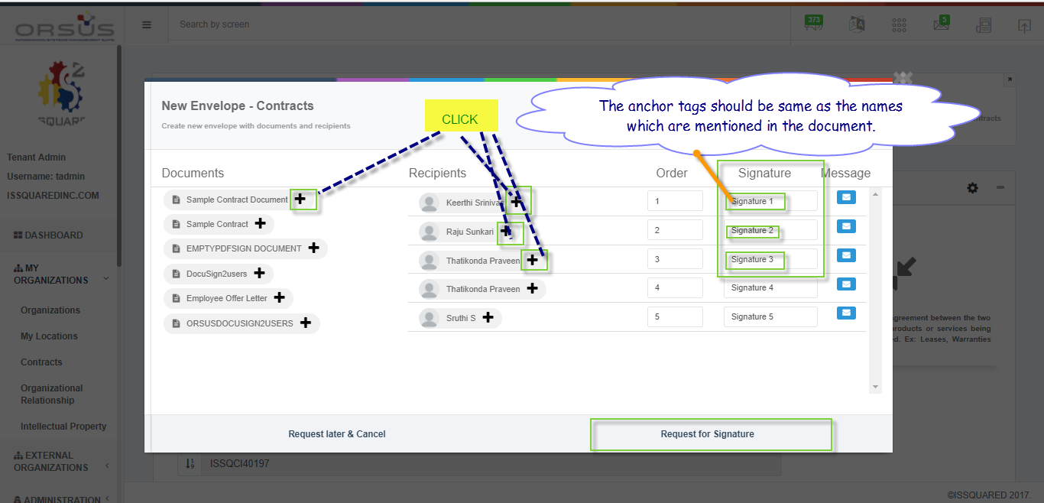

11. Once the signature is requested then an email will be triggered to all the users which are mentioned in the envelope and the status of the DocuSign will change to **In Process**.

12. After completing the signatures from all the users successfully then the Status will change to **“Completed”** and the certificate options gets displayed on the envelopes screen.

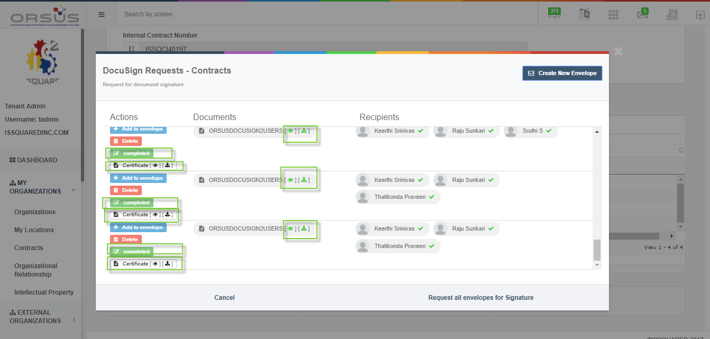

***\*\*\*\*\*\*Here the Recipients mail ids should be valid then only the emails will be sent. \*\*\*\*\*\****